**OreSat Reaction Wheel Control**

**Project Outline (rough draft)**

Josh Lake Fall 2017 Portland State University

Sponsor: PSAS

1. Understand Requirements of Project (Deliverables):

* Given an input angle Θin for x, y and z axis (in a local coordinate system), develop controls for a reaction wheel system for the OreSat satellite such that the output will be a Θout for x, y and z axis that is within ±1° of the input Θin.
* Reaction wheel system must not exceed an allotted mass determined by PSAS
* Motors used must be brushless DC motors (off the shelf)
* PSAS has suggested using the magnet and casing of the DC motor as the reaction wheel (with rotor held stationary allowing the magnet and casing to rotate). PSAS has done a proof of concept with this approach.

(Signal noise due to using magnet as spinning mass?)

1. Analyze and understand the system and its transfer function(s):

* Start with free body diagram of OreSat
* Develop general transfer function for Θ(out OreSat)/Θ(reaction wheel) based on analysis of free body diagram
* Develop general transfer function for DC motor
* Understand the dynamic response required by motor (angular acceleration required to supply required torque)
* Understand how to determine required input voltage to motor based on input angle Θin

1. Select and test candidates for DC motor based on analysis in step 1. :

* Select a small number of off the shelf candidates for the motor to be used
* Create test fixture for the motor in order to measure angle (RPM)
* Perform time domain analysis for each motor (Bode)
* Analyze response of motor given a step input. Analyze rise time and overshoot.
* Determine best candidate of motor based on analysis above

1. Control Design

* After specific DC motor has been chosen order three more and repeat time domain analysis on the motors not already tested.
* Develop a controller design that is specific for each motor in order to achieve appropriate rise time and overshoot (minimize overshoot).
* Perform necessary number of iterations

1. Simulation

* Use the motor information found in 2 and 3 to use in the general transfer function of the system.
* Create a test set-up with Matlab/Simulink and/or Labview to test the response of all four motors acting together.
* For a given step input of angle for x, y and z axis for OreSat test the response of the motors working together. Using the measured change in position over time of the motors calculate the corresponding torque and use this information to find the theoretical response from OreSat using simulation software mentioned.
* Analyze the rise time and overshoot of the theoretical position response of OreSat.
* Perform necessary number of iterations

1. Build Prototype ( Start early )

* Build a prototype of OreSat with specified dimensions (perhaps just the frame so the motors can be observed
* Weigh the prototype with motors and control infrastructure added
* Add additional weight (to the center of gravity) until the inertia of the prototype is an acceptable approximation of the original.

1. Test

* Hang prototype along each axis and test response to a step input.
* If prototype fits, test in drop tower with an initial impulse giving to supply a rotation that the reaction wheels will attempt to stabilize (proof of concept has been performed with a smaller prototype and brushed DC motors).
* If problems arise, go back to appropriate step and perform necessary iterations.

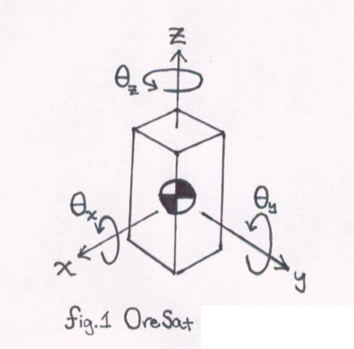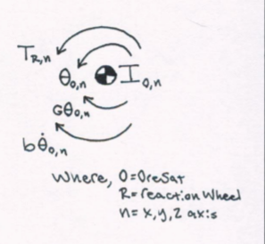

(Transfer function development next page)

